**Team Members:** David Pace, Andy Tran, and Lisa Gilmore-Montero

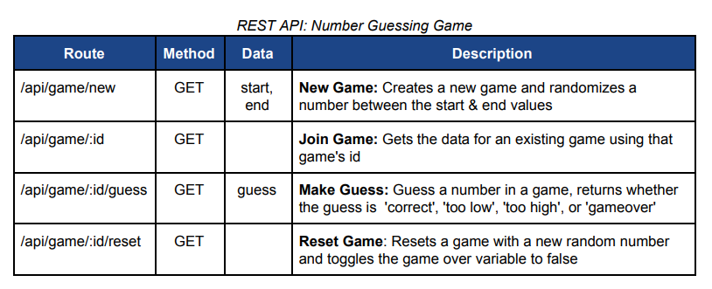

| Route | Method | Data | Description |
| --- | --- | --- | --- |
| /store-data | GET | JSON of basic store-front, includes all categories and products | Returns **Product List** and **Category List** in a single get request |
| /products | GET | Json of products  img  link  name | **Product List**: Displays list of all the products  Will get data from a database. |
| /categories | GET | Json of categories  ID  name | **Category List:** Displays list of all categories  Will get data from a database |
| /productList/guest/update | POST/GET | Search,  Sort/Filter,  Categories | **Product List:** Update the list of products. Updating the products in the list can be done through using the search engine feature, sort & filter feature, or changing the category using the navigation bar  Will get the updated list from a database |
| /productList/guest || userID/cart | GET |  | **Cart:** View the shopping cart  Will get the data from a database.  Update the view by having a modal appear |
| /user/cart/:cartid/add | POST | AddToCart, Body {productID} | **Cart:** Can add item to cart of :id |
| /user/cart/:cartid/remove | POST | RemoveFromCart,  -Body {productID} | **Cart:** Can remove item to cart of :id |
| /productPage/guest | GET |  | **Product View:** Display product information |
| /productList/userID |  |  | **Product List**: Displays list of all the products |
| /productList/userID/update | POST | —-------------------- | **Same as guest/update** |
| /productList/userID/cart | GET | —--------------------- | **Same as guest/cart** |
| /productList/userID/cart/update | POST | —--------------------- | **Same as guest/cart/update**  Changes to the cart will need to make changes in the database for specific user |
| /productPage/userID | GET | —--------------------- | **Same as productPage/guest** - but can also add item to wishlist |
| /productList/userID/wishlist/update | POST/GET | AddToWish | **Wishlist:** Can add item to wishlist in productList view  A modal will appear in the view in order to choose which list to add it too |
| /productList/userID/wishlist/create | POST | CreateList | **Wishlist:** Can create a wishlist  Option in the wishlist modal is too create a wishlist. This wishlist will be added to the user’s account |
| /accountPage/userID/wishlist | GET |  | **Wishlist:** Display the different wishlist when on the accountPage  Accesses the user’s database information |
| /accountPage/userID/wishlist/update | POST | EditList | **Wishlist:** Can edit a wishlist  Can remove an item from a user’s wishlist. Will need to update the changes in the database |
| /accoutPage/userID/wishlist/delete | DELETE | DeleteWishlist | **Wishlist:** Can delete wishlist  Will need to delete wishlist in the database |
| /accountPage/userID/logout |  | Logout | **Logout**: Logout of account  User authentication - need to logout |
| /accountPage/userID/accountInfo | GET |  | **Account Info:** Display account info  User authentication  Access user’s information in the database |
| /accountPage/userID/accountInfo/update | POST | EditAccountInfo | **Account Info:** Can edit account info  User authentication  Need to make update the account info |
| /accountPage/userID/password | GET |  | **Change Password:** view change password page |
| /accountPage/userID/password/update | POST | EditPassword | **Change Password:** can change password  User authentication  Changing password in database |
| /productList/admin | GET |  | **Product List**: Displays list of all the products  Need to access data from database |
| /productList/admin/update | POST/GET | Search,  Sort/Filter,  Categories | **Product List:** Update the list of products. Updating the products in the list can be done through using the search engine feature, sort & filter feature, or changing the category using the navigation bar  Will get updated list from database and will change the view to display updated list |
| /productList/admin/deleteProduct | DELETE | RemoveProduct | **Product List:** Remove product from list/ pops up modal to confirm deletion  Will need to delete product in the database |
| /productPage/admin | GET |  | **Product List:** Display Product information  Access product information from the database |
| /productPage/admin/addFeature | POST/GET | AddFeature | **Product Page:** Add Feature - modal will pop up in the view for inserting information |
| /productPage/admin/removeFeature | DELETE | RemoveFeature | **Product Page:** Remove Feature - modal will pop up in the view to remove features |
| /productPage/admin/update | POST | UpdateProduct | **Product Page:** Update product information  Changes made will be used to update the product’s information in the database  Will need the products id |
| /accountPage/admin/accountInfo | GET | —----------------------- | **Same as userID/accountInfo** |
| /accountPage/admin/accountInfo/update | POST | —----------------------- | **Same as userID/accountInfo/update** |
| /accountPage/admin/password | GET | —----------------------- | **Same as userID/accountInfo/password** |
| /accountPage/admin/password/update | POST | —----------------------- | **Same as userID/accountInfo/password/update** |
| /accountPage/admin/AddProduct | GET |  | **Add Product:** Display add product view  Will get corresponding html code and will appear in the view |
| /accountPage/admin/AddProduct | POST | CreateProduct | **Add Product:** Input product information and add new product  Will need to add new product to database |
| /accountPage/admin/logout | GET | —---------------------- | **Same as userID/logout** |
| /accountPage/admin/marketplace | GET |  | **Marketplaces:** Displays all products |
| /accountPage/admin/marketplace/add | POST | AddToMarket | **Marketplace:** Can add product to marketplace and marketNotification displays |
| /accountPage/admin/marketNotification | GET | MarketAlert | **Marketplace modal**: Displays requirements for specific market place |
| /accountPage/admin/marketID | GET |  | **MarketID:** Displays specific marketplace and marketNotification appears if requirements are not satisfied |
| /accountPage/admin/marketID/updateItem | DELETE | DeleteFromMarket | **Same as productList/admin/deleteProduct** |
| /accountPage/admin/marketID/edit | POST | UpdateProduct | **Changes view to a similar view to /productPage/admin/update - still in accountPage though - returns back to marketID after changes are saved** |
| /accountPage/admin/marketID/overview | GET |  | **Market Overview:** Display stats  Get this information by using an API to the market place |
| /accoutPage/admin.marketID/delete | DELETE | DeleteMarket | **Same as /userID/wishlist/delete** |
| /checkout | GET |  | **Checkout**: Displays the items in cart |
| /checkout/userID | GET |  | **Checkout**: Displays the items in cart  Will get cart info from the database using the userID |
| /checkout/userID/update | POST | editCart | **Checkout**: Can make changes to the cart  Need to update the changes to the database |
| /login | POST | Login | **Login:** input login info - can get to this page from /productList/admin || guest  User authentication |
| /signup | POST | SignUp | **SignUp:** sign up - can get to this page from/productList/admin || guest/  User authentication |

Note: Guest endpoints will be public, user endpoints will be private, and admin endpoints will also be private.

**Tooling & Libraries**

Express

Express-Session

Express-Flash

Passport

Passport-Local

Bcrypt

Dotenv

shortid

cors